**Green Society Public School**

**Ratnanagar-7, Sauraha, Chitwan**

**Second Terminal Examination-2082**

**Class: Nursery Time: - 2 hrs. F.M.: 50**

**Sub: English (W)**

|  |
| --- |
| **Name: Roll No.: Sec.:** |
| **­­­­­­­­­­­­ ________________ ______________ OBT.MARKS:**  **INVIGILATOR EXAMINER** |

**1) Match the letters with the correct pictures. (6)**

A

M

C

U

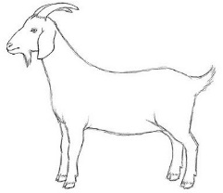W

Q

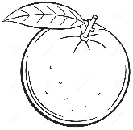**2) Write the first letter of the pictures. (3)**

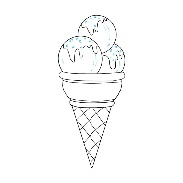

__________ ___________ __________

**3.) Circle the letter ‘P’ (5)**

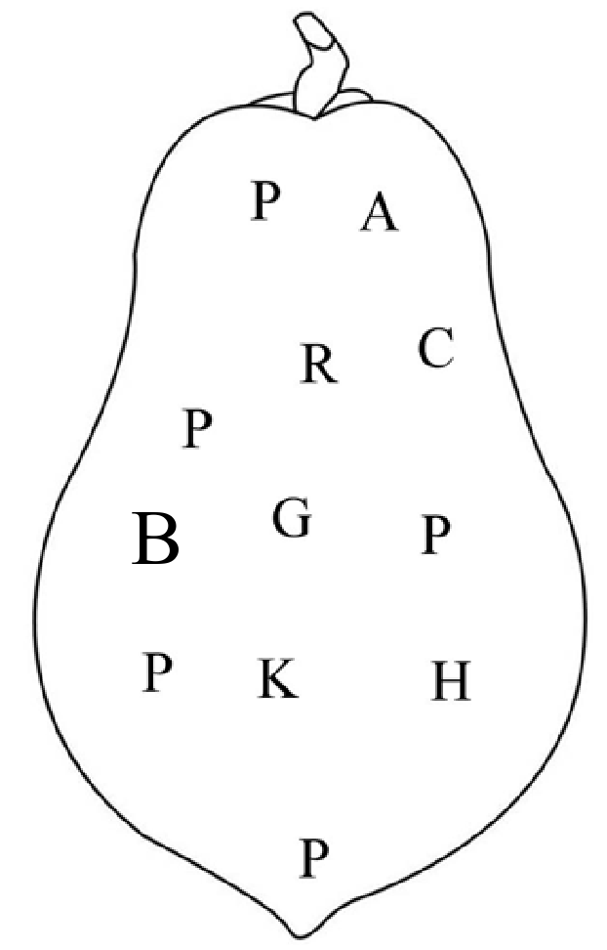

**4) Match the missing letters. (5)**

G _________ I _________ J _________ K

_________ M _________ O _________

**5) Match the same capital and small letters. (5)**

B h

H b

J q

M j

Q m

**6) Write (Aa to Ff). (12)**

_______ _______ _______

_______ _______ _______

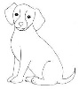**7) Circle the letters according the given pictures. (5)**

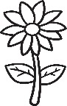 : D A C

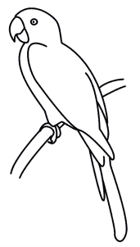 : G F B

: K P M

 : N R D

: E I H

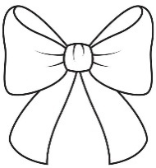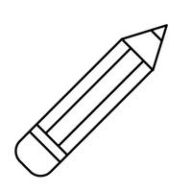**8) Match the same pictures. (4)**

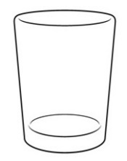

**9) See the letter and colour the correct pictures. (5)**

Kk

Mm

Gg

Ii

Ll

**The End**